12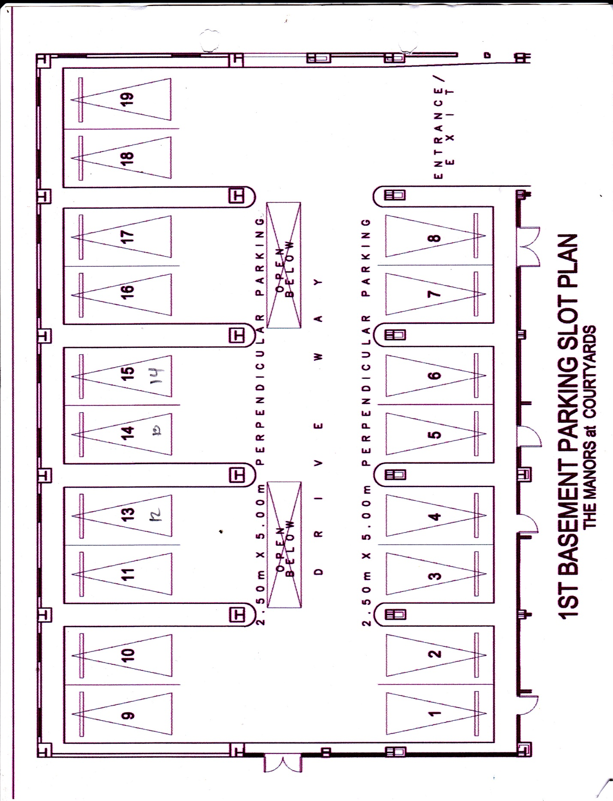

13

1

18

14

10

9

12

11

16

15

17

8

7

6

4

3

**The Courtyards Parking Space**

**YELLOW – OPEN UNITS**